[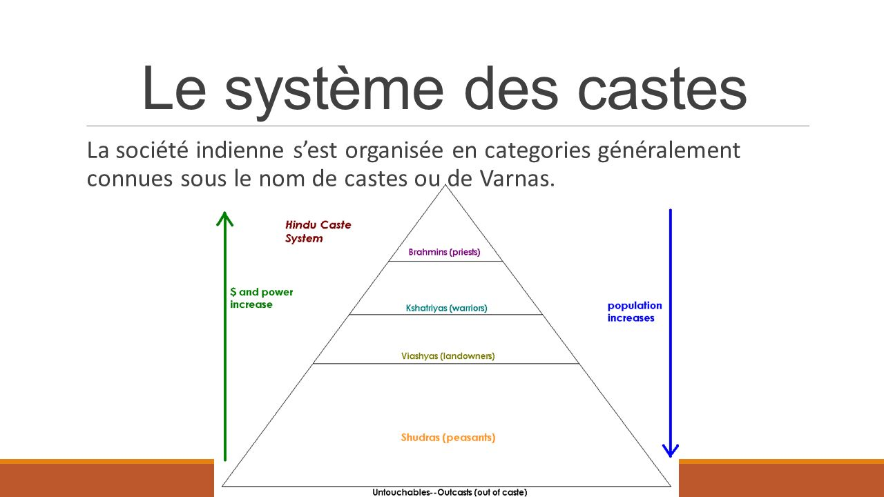](https://www.google.fr/url?sa=i&rct=j&q=&esrc=s&source=images&cd=&cad=rja&uact=8&ved=2ahUKEwjBm9HjxdraAhVOsaQKHeIvA8sQjRx6BAgAEAU&url=http://slideplayer.fr/slide/10888827/&psig=AOvVaw2XKBT5KQvwd3uagzOsTbdw&ust=1524921527015113)